Project 7
Due 12/10/2017 by 11:59 PM
No delay is accepted
For each day late submission 2 points penalty is incurred.
Post your answer in the folder Project7 on the blackboard.
If you have any question please email me at mbadii@pace.edu

Do not delete anything from this file. Just write your answer under the word: Answer.

This is the programming assignment 4.2 on pages 206-207of your textbook. Copy/paste your parallel program under the word: Answer in this document.
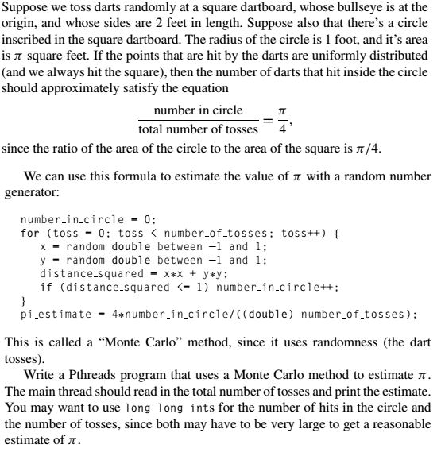
Complete the program under the word: Answer.
Note: You must only guard line(s) of the program that the threads change the content of a shared variable.

The sequential program for this algorithm is:

//File name: a.c
#include <stdio.h>
#include <stdlib.h>
#include <time.h>
//Returns a random number in the range -1 and 1.
double rand_double() {
return 2 * (rand() / (double)RAND_MAX) -1;
}

int main() {
double x, y, distance_squared, pi_estimate;
int number_in_circle = 0, toss, number_of_tosses;
printf("Enter number the total number of tosses: ");
scanf("%d", &number_of_tosses);

srand((long)time(NULL));

for (toss = 0; toss < number_of_tosses; toss++) {
x = rand_double();
y = rand_double();
distance_squared = x*x + y*y;
if (distance_squared <= 1)
number_in_circle++;
}
pi_estimate = 4 * number_in_circle / ((double)number_of_tosses);
printf("Estimated pi = %f\n", pi_estimate);
return 0;
}

Answer:
#include <stdlib.h>
#include <pthread.h>

long long int total_number_of_tosses; //Total number of tosses
long long int number_in_circle = 0; //Each thread is adding its result to this variable.
int thread_count; //Number of threads.
pthread_mutex_t hitNum_mutex; //To guard the share variable.

void *thread_toss(void* rank); //Each thread calls this function.

int main()
{
double pi_estimate;//At the end the function main stores the output into this variable and print it.
long thread; //Use as a control variable in a for-loop.
pthread_t* thread_handles;

printf("Enter number of threads and the total number of tosses: ");
scanf("%d%lld", &thread_count, &total_number_of_tosses);
//Using the following loop to make it divisible by thread_count.
while (total_number_of_tosses % thread_count == 0) total_number_of_tosses++;
//Complete the rest of this function.

return 0;
}

//returns a random number in the range -1 to 1.
double rand_double() {
return 2 * (rand() / (double)RAND_MAX) - 1;
}

void *thread_toss(void* rank) {
//Complete this function

return NULL;
}

